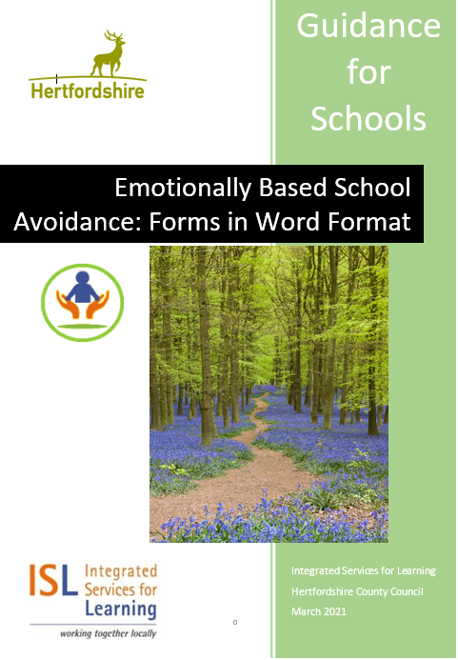

**Purpose of this document**

Some of the forms included in the “Emotionally Based School Avoidance: Guidance for schools” document are more easily completed in word format. These forms are collated in this document for ease of use.

**Contents**

Appendix 15: Framework for gathering information from parents 3

Appendix 16: Round Robin – example questions when working with school staff 5

Appendix 32. Checklist for early intervention to address EBSA 7

Appendix 33. Checklist of strategies for CYP with EBSA 10

## Appendix 15: Framework for gathering information from parents[1]

|  |  |
| --- | --- |
| **Name of child:** | **Date:** |
| **Present at meeting:** | |
| **Developmental and educational history** | |
| What was s/he like as a young child? Can you tell me about their early experiences at school? The primary school, at the start of secondary school? |  |
| **Strengths, interests and aspirations** | |
| What is s/he good at?  What do they like doing?  Do they have any hopes for the future?  Do they know what they want their life to be like when they are an adult? |  |
| **Any potential changes or losses within the family or child’s life** | |
| Can you tell me about your family? Who is in it, who is like whom? Who is s/he closest to? Have there been any changes within the family recently?  *(You could ask the family to draw a family tree/ genogram)* |  |
| **Relationships** | |
| Does s/he talk about any other children? What does s/he say?  Does s/he talk about any adults within school? What does s/he say?  Who does s/he get on with? Who doesn’t s/he get on with? |  |
| **Academic progress** | |
| *Please note: the school should be aware if the young person has identified SEN needs and should ask about these needs and the support in place.*  *If there is no identified SEN school should ask if they have any concerns, or if the child has spoken about difficulties.* |  |
| **The child’s view what are their specific fears/worries** | |
| Has s/he spoken to you about what s/he finds difficult about school? What do they say? |  |
| **The child’s views, what is going well in school** | |
| Has s/he mentioned anything that is going well in school? (e.g. teachers, lessons, friends) |  |
| **Behaviour and symptoms of anxiety** | |
| When s/he is worried what does it look like? What do they say they are feeling? |  |
| **Typical day – when they go to school and when they don’t go to school** | |
| Please describe a typical day when s/he goes to school from the moment s/he gets up until s/he goes to bed. What about when s/he doesn’t go to school? What does s/he do when they do not go to school? What do other family members do? |  |
| **Impact on various members of the family** | |
| How does their non-attendance impact on you? And on other family members? Who is better at dealing with the situation? Why? |  |
| **Parental views on the reasons for the EBSA** | |
| Why do you think s/he has difficulty attending school?  *(Ask each parent separately)*  If (the other parent/carer/sibling/ grandparent) were here what would they say? Are there any differences of views about the reasons and what should be done within the family? |  |
| **Exceptions to the problem** | |
| Have there been times when s/he managed to get into school?  What was different about those times? |  |
| **Previous attempts to address the problem** | |
| What has been the most helpful thing that someone else has done in dealing with the problem so far?  What has helped in the past when things have been difficult?  What strategies have been most helpful so far in managing their anxiety? |  |

## Appendix 16: Round Robin – example questions when working with school staff[2]

|  |  |
| --- | --- |
| *___________ is currently experiencing difficulties attending school, which we feel may be due to emotional distress. We would like to gain a picture of how ___________ is doing in school. As an adult who works with __________, please complete the questions below.* | |
| Your name _______________ | Lesson/activity taught _________________ |
| Please describe ____________ | |
|  | |
| What are __________’s strengths? | |
|  | |
| What is going well for ___________? | |
|  | |
| What does ___________ find difficult? | |
|  | |
| How does ___________ get on with their peers? | |
|  | |
| How does _______________ get on with you and other adults? | |
|  | |
| Is ____________ engaged and motivated with their learning?  Is s/he making progress? If not, why not? | |
|  | |
| Have you observed any emotional difficulties at school? What have these been? When did/do they occur? | |
|  | |
| What support do you provide for _____________? How do they respond to this? | |
|  | |
| What is your understanding of _____________’s attendance problems? | |
|  | |
| What do you think would help ___________ in school? | |
|  | |

## 

## Appendix 32. Checklist for early intervention to address EBSA

|  |  |  |
| --- | --- | --- |
| **Child’s name:** | **Year group:** | **Class/Form teacher/HOY:** |
| **Parent/carer names and contact details:**  **(Times when they are available)** | | |
| **Number of days absent to date and reasons provided for absence:** | | |
| **Observation of any of the following behaviours:**  Changes in pupil behaviour in lessons (e.g. behaviours indicating anxiety)  Pupil complaining of illness to avoid attending school  Pupil telling their parents that they don’t want to go to school  Pupil having difficulties attending some or all lessons  Periods of lateness or missing lessons  Reduced attendance which may show a pattern  Regular absences or sporadic attendance  Weeks of non-attendance;  Pupil rarely leaving their house/bedroom, even if not school related.  Other: | | |
| **Relevant background information**  Any significant life event(s). Relevant details:    Any family/social or economic challenges. Relevant details:  Any medical needs or recent illnesses    Any Special Educational Needs and EHCP. Relevant details:  Any previous professional involvement. Relevant details: | | |

|  |  |  |
| --- | --- | --- |
| **Actions undertaken to date** | **Date of action taken and by whom** | **Follow up Actions** |
| **Discussion with child**  *Consider: learning, friendships, self-esteem, bullying issues, home life, engagement in after-school activities etc. (see EBSA Guidance Document p20-21)* |  |  |
| **Discussion with parent**  *Discuss recent events (conflict, loss, illness etc.) and their perspective on the absence.*  *(see EBSA Guidance Document p21)* |  |  |
| **Discussion with relevant staff member(s)**  *Consider: attainment, SEN, learning support, pastoral support, recent transitions, stability of school personnel, pupil-staff relationships etc*.  *(see EBSA Guidance Document p21-22)* |  |  |
| **Identification of Risk and Resiliency factors** *Based on discussions with pupil, parent and staff, identify risks/resiliency factors (see pages 16 – 18) and draw up a PUSH/PULL Matrix.* |  |  |
| **Implementation of an Assess, Plan, Do, Review Action Plan**  *Based on the above discussion and understanding of this pupil’s unique situation, what further information is needed and how will that be obtained; what support can be put in place; how and when will it be reviewed.*  *(See strategies outlined in EBSA guidance document p23-38)* |  |  |
| **Consideration of appropriateness of involvement of other professionals after one APDR cycle:**   * *Attendance Team* * *ISL Specialist Advisory Teachers* * *Educational Psychologist* * *School Nurse* * *ESMA* |  |  |
| **Notes** |  |  |

## Appendix 33. Checklist of strategies for CYP with EBSA

|  |  |
| --- | --- |
| **Likely to be relevant for all CYP with EBSA** | |
| **Strategy** | **Further details – how/ when / who** |
| Allocate the CYP key adults in school |  |
| Have clear consistent routines for warmly welcoming the CYP to school |  |
| Ensure the CYP knows what will happen during the day, including what will happen in unstructured times. |  |
| Enable readiness for learning by introducing calming activities at the start of the day. |  |
| Teach the CYP how to recognise, label and self-regulate their feelings |  |
| Proactively adapt the environment to reduce triggers for anxiety. |  |
| Make a plan in advance with the CYP about what will happen if they become anxious |  |
| Build the CYP’s confidence in their ability to manage their anxiety |  |
| Develop the CYP’s motivation to be in school. |  |
| Keep in contact with students who are not attending school at all. |  |
| Share the document “Emotionally Based School Avoidance: A Guide for Parents and Carers” with families when it becomes available. |  |
| **For CYP who feel overwhelmingly anxious or sad about attending school** | |
| Address the specific worry or difficulty identified during assessment e.g. sensory difficulties, learning needs, bullying etc |  |
| **For CYP who want to avoid difficult social situations or situations where they feel evaluate** | |
| Teach social skills and mindful acceptance |  |
| Help develop self-esteem |  |
| Teach the CYP how to check for thinking errors |  |
| Teach social problem solving |  |
| **For CYP who need attention and contact with parent / carers.** | |
| Have an organised “meet and greet”, with a routine for saying goodbye to the parent/carer; |  |
| Introduce a transitional object; |  |
| Encourage the parent/carer to manage their own anxiety |  |
| Consider referring to other agencies if the family needs support; |  |
| If CYP has a background of trauma or abuse, consider allocating a “key adult” who takes on the role of an additional attachment figure. |  |
| **For CYP engaging in pleasurable and rewarding activities while at home during the school day (e.g. gaming** | |
| Encourage and support the parents/carers to set limits on their child’s behaviour. |  |
| **For CYP who are about to experience transition (e.g. new school, new class, returning to school after absence etc)** | |
| Develop a detailed transition plan and share this with CYP and family. |  |

1. West Sussex EBSA guidance
2. West Sussex EBSA guidance